Table 3 SSE parameters
SSE consists of two exercise movements (1) Lie on the back and lift legs to enlarge the power of tendons, (2) Touch the feet with both hands to reinforce the kidney
(1) Lie on the back and lift legs to enlarge the power of tendons | 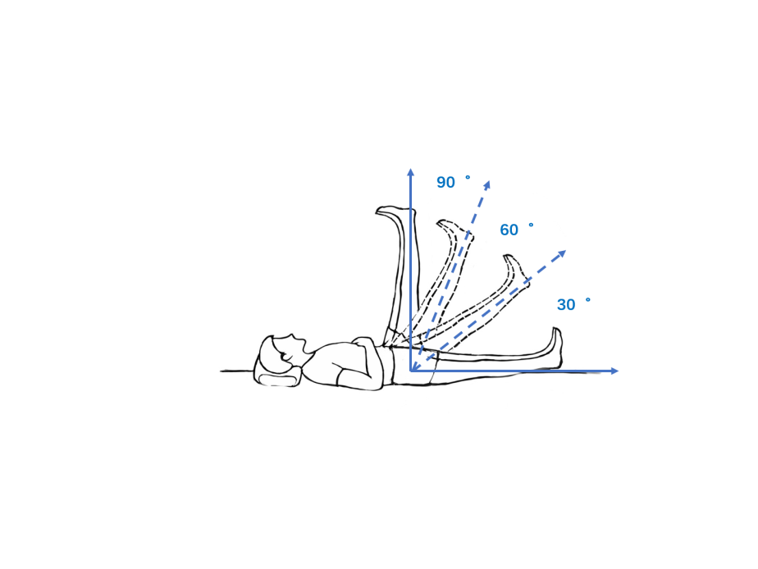
 | ①Tips | Lie on the back, with the body limbs naturally relaxed, keeping legs straight and close together, and then slowly raise two legs at a constant speed. In the process of raising the legs with deep inhalation, the breath is held at the highest position, and the gesture is kept for 3 seconds, followed by putting down the legs slowly at an even speed and exhaling in this process.
 | ②respiration and thoughts | Keep the breathing even during the lifting and lowering of legs. Eliminate distracting thoughts during exercise and concentrate on the low back.
 | ③exercising frequency | According to individual physical condition, 5-10 times every morning and evening. Specific staged exercise requirements: Week 1-4, retention time 3 seconds, 3-5 times; Week 5-8, retention time 5 seconds, 5-8 times; Week 9-12, retention time 8 seconds, 8-10 times.
(2) Touch the feet with both hands to reinforce the kidney | 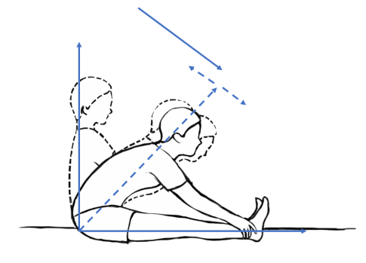
(2) Touch the feet with both hands to reinforce the kidney | ①Tips | Sit on the bed, keeping legs straight and close to the bed, with deep exhalation while the upper body bends forward and the upper limbs straighten, both hands trying to touch the farthest part of the lower limbs. Then look forward and imagine a rope in the mind pulling the mandible towards the toes, during which the breath is held, and the gesture is kept for 3 seconds. Finally, loosen the hands, inhale deeply, return to the sitting position and bend the hip.
(2) Touch the feet with both hands to reinforce the kidney | ②respiration and thoughts | Keep the breathing even during bending the upper body and returning to the sitting position. Eliminate distracting thoughts during exercise and concentrate on the low back.
(2) Touch the feet with both hands to reinforce the kidney | ③exercising frequency | 5-10 times every morning and evening. Specific staged exercise requirements: Week 1-4, retention time 3 seconds, 3-5 times; Week 5-8, retention time 5 seconds, 5-8 times; Week 9-12, retention time 8 seconds, 8-10 times.
notes | ①Patients should gradually increase the amount of exercise according to the recommended dose from small to large. ②If there is any discomfort during the exercise, stop the exercise immediately and contact the doctor. The doctor evaluates whether to continue exercising.
quality control | ①All patients are evaluated by a senior doctor before formal exercise. The assessment mainly relates to whether the patient is suitable for exercise and whether the patient has fully mastered the exercise. ②At the end of the 4th, 8th and 12th week, the investigators examine the subjects' practice at home to ensure the accuracy of their movements. ③The doctor provides exercise instruction video materials for all patients, including the purpose, action decomposition, and main points. ④The investigator's mobile phone number is provided for the patient so that he/she can contact the doctor at any time to answer their questions.
duration | 12 weeks

